MIDTERM EXAM & SOLUTIONS

Maximum = 100
Minimum = 31
Average = 76
Median = 78
Standard Deviation = 16

1. (20 points) What can you conclude?

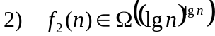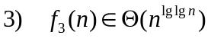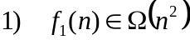Given:

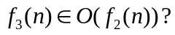a) (10 points) Can we conclude from statements (1)-(3) that

Why or why not? Either prove or provide a counterexample.

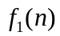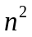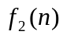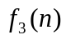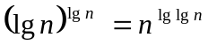

SOLUTION: YES.

First, observe that 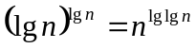. This can be verified by taking lg of both sides. Next, 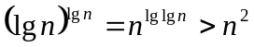 because lglgn > 2 for n > 16. From this we obtain the picture above.

To show that 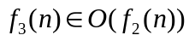, we first use the definition of Θ to conclude that 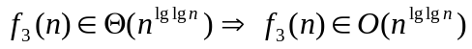. Since 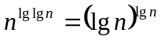, this implies, transitively, that 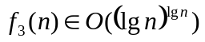. Now, 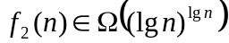 implies, using transpose symmetry, that 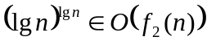. Thus, transitively, .

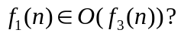b) (10 points) Can we conclude from statements (1)-(3) that

Why or why not? Either prove or provide a counterexample.

SOLUTION: NO. Counter-example: 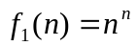 and 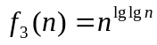.

2. (20 points) Recurrence

In this problem, you will find a tight upper and lower bound on the closed-form solution for the following recurrence:

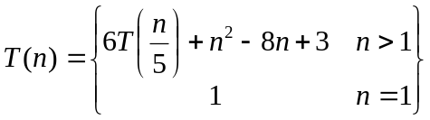

That is, find the smallest function 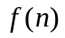 that you can, such that 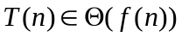.

You may assume that n is a power of 5.

SOLUTION: The Master Theorem can be applied, with a = 6, b = 5 and f(n) = n² – 8n + 3. We first simplify f(n) to Θ(n²). Then the ratio test yields: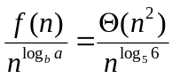. Now, observe that: 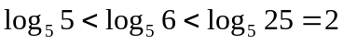. This implies that 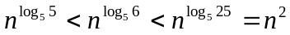. Thus, 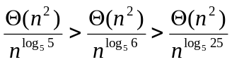, which is Case 3 with 0 < ε < 1. Therefore, 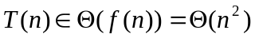.

3. (20 points) Randomized Algorithm

Consider the following pseudocode:

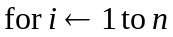
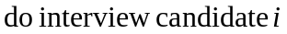
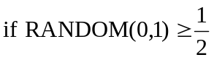
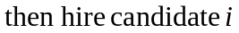

Derive a tight upper bound on the expected hiring cost as a function of c_{h} and n.

Hint: You may assume that the call RANDOM(0,1) is equally likely to produce a number 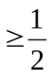as it is to produce a number 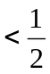.

SOLUTION: Let X be a random variable representing the number of candidates hired. The expected hiring cost is then c_{h}E[X]. To calculate E[X], we use indicator random variables. Let Y_{i} be the event that candidate i is hired.

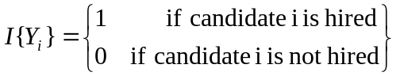

Define an indicator random variable 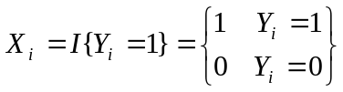.
Now, 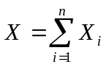, so 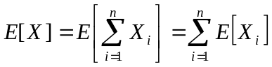 by linearity of expectation. 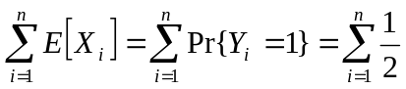 because the call RANDOM(0,1) is equally likely to produce a number as it is to produce a number . Thus, 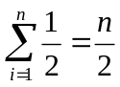, so a tight upper bound on the expected hiring cost is 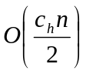 .

4. (40 points) Designing an Algorithm

In this problem you will design an efficient algorithm LARGEST_GAP that solves the following problem:

- Given a list of n distinct integers in an array A[ 1…n ]
- For each A[ i ] (except the largest), let i_{max} be the index of the number closest in value to A[ i ] that is > A[ i ]. For the largest value in A, let i_{max} = i.
- Find 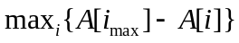. That is, find the largest difference between A[ i_{max} ] and A[ i ] across all the different values of i.

Example: For A = < 10, 3, 12, 1, 11, 2 >, LARGEST_GAP returns 7.

Your algorithm should not use more than Θ(1) additional storage beyond A.

- (14 points) Pseudocode. Describe your algorithm using the pseudocode conventions in our textbook.

SOLUTION:

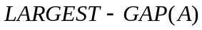
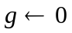
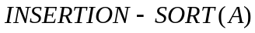
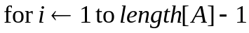
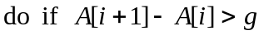
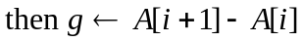
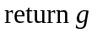

- (13 points) Correctness Justification.

SOLUTION: We claim that, at the end of LARGEST-GAP’s execution, 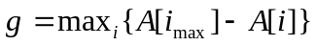. The first assignment statement initializes g to 0. We use 0 because we want the maximum value. Next, we call INSERTION-SORT to sort the array into nondecreasing order. Its correctness is established in our textbook on p. 17-19. Note that we do not call MERGE-SORT. This is because the problem prevents us from using more than Θ(1) additional storage, and MERGE-SORT in the text uses Θ(n) additional storage. Once A is sorted, for each element A[i_{max}] is immediately adjacent to A[i] and to its right (except for the last element, for which i_{max} = i). Therefore, . This means we can find by stepping through A, calculating A[i+1]-A[i] for each element i, and storing the maximum difference in g. This is what the for loop does. Note that the loop terminates correctly because the upper bound on i is length[A]-1, so A[i+1] does not exceed the bounds on the array. The final step of the pseudocode returns g, which is guaranteed to be .

- (13 points) Running Time Analysis. Give a worst-case asymptotic upper bound on the running time of your algorithm as a function of n. Explain your answer.

SOLUTION: An upper bound on the worst-case running time of LARGEST-GAP is O(1) + O(n²) + O(n). The O(1) come from the initialization of g and the return statement. The O(n²) is an upper bound on the worst-case running time of INSERTION-SORT. The O(n) is the time for the for loop. The total time is therefore in O(n²).

(Note that using a sorting algorithm with smaller worst-case running time than O(n²) would speed up LARGEST-GAP. In Chapter 7 and beyond we see some sorting algorithms whose worst-case running time is better than O(n²), yet they only use Θ(1) additional storage.)

